SPECIAL NOTE FOR PAVEMENT WEDGE AND SHOULDER
MONOLITHIC OPERATION

1.0 MATERIALS. Provide an Asphalt Surface Mixture conforming to Section 403 of the Standard Specifications, as applicable to the project, for the pavement wedge.

2.0 CONSTRUCTION. Place the specified Asphalt Surface Mixture on shoulders monolithically with the driving lane. Prime the existing shoulder with tack material as the Engineer directs before placing the wedge. Construct according to Section 403.03 of the Standard Specifications.

Equip the paver with a modified screed that extends the full width of the wedge being placed and is tapered to produce a wedge. Obtain the Engineer’s approval of the modified screed before placing shoulder wedge monolithically with the driving lane.

The wedge may vary in thickness at the edge of the milled area in the shoulder. If the area to receive the shoulder wedge is milled prior to placement, during rolling operations pinch the outside edge of the new inlay wedge to match the existing shoulder elevation not being resurfaced. Unless required otherwise by the Contract, construct rolled or sawed rumble strips according to Section 403.03.08, as applicable.

The following sketch is primarily for the computation of quantities; however, the wedge will result in a similar cross-section where sufficient width exists. Do not construct a shoulder for placing the wedge unless specified elsewhere in the Contract.

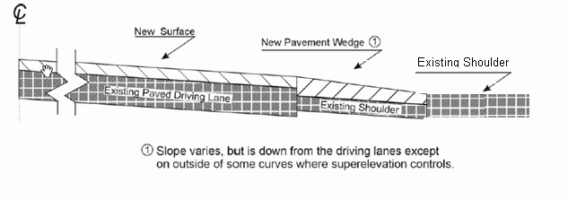

3.0 MEASUREMENT. The Department will measure Asphalt Surface Mixture placed as the pavement wedge according to Section 403.

4.0 PAYMENT. The Department will make payment for the completed and accepted quantities of Asphalt Surface Mixtures on pavement wedges according to Section 403.

1-3232-DS Pavement Wedge Monolithic
01/02/2012

